Tuesday, June 30, 2026

Dear Owner,

NOTICE OF ANNUAL GENERAL MEETING OF THE BODY CORPORATE FOR [PROPERTY_NAME] CTS [CTS]

You are advised that the Annual General Meeting of the Body Corporate for [PROPERTY_NAME] Community Title Scheme [CTS], is to be held at [LOCATION] on [DATE] at [TIME].

Should the general meeting be adjourned due to a lack of quorum, the meeting will be reconvened at the office of DCS Management Pty Ltd, Shop 1/80 Hornibrook Esplanade, Clontarf, seven (7) days following the meeting unless otherwise advised. If you have any queries or concerns, please do not hesitate to contact this office.

The following agenda sets out the substance of the motions to be considered at the meeting. The full text of each motion is set out in the accompanying Voting Paper. An explanatory note may accompany the agenda.

If you are unable to attend the meeting you have the following options to return your completed voting papers:
- To complete an electronic vote go to www.dcsmanagement.au and enter the following code: [CTS]
- Scan and email the voting pages to admin@dcsmanagement.au or
- Post a hard copy to PO Box 253, Clontarf QLD 4019
The last item of business is the Election of Committee Members. Nominations will be called from the floor of the meeting to elect members to vacant positions. An owner, who does not owe a body corporate debt at the time of the meeting, may nominate individuals for election as a voting member of the committee orally from the floor of the meeting or in writing handed to the person chairing the meeting. However, to be entitled to vote in the election, a person must be present at the meeting.
AGENDA:
Attendance record and Apologies
Admittance of proxies and voting papers

MOTIONS:

- Adoption of Minutes
- Statement of Accounts
- No Audit
- Appointment of Auditor
- Administration Fund Levy
- Insurance Levy
- Sinking Fund Levy
- Insurance
- Appoint Body Corporate Manager
- Re-appoint Body Corporate Manager
- Electronic Voting
- …

ELECTION OF OFFICE BEARERS:
The following nominees will be declared elected at the meeting:
POSITION | NOMINATOR | UNIT / LOT | NOMINEE | UNIT / LOT | LOT OWNER
Chairperson
Secretary
Treasurer
Ordinary member
Nominations will be called from the floor of the meeting to elect members to the positions of Chairperson, Secretary & Treasurer (and Committee if required).

ATTACHMENTS TO THIS NOTICE INCLUDE:
- Minutes of last general meeting
- Annual Financial Statement
- Independent Auditors Report
- Proposed Administration & Sinking Fund Budgets
- Certificate of Currency
- DCS Management Agreement

Regards,
DCS Management Pty Ltd,
for the Secretary [PROPERTY_NAME] CTS [CTS]
PO Box 253
CLONTARF Q 4019
admin@dcsmanagement.au

STATEMENT REGARDING MEETING PROCEDURE AND VOTERS RIGHTS FOR A GENERAL MEETING
- Regulations* define who is entitled to vote at a meeting of the Body Corporate.
- The Regulations** set out how a person can vote at a meeting of the Body Corporate.
- A notice is enclosed for a corporate owner to appoint a company nominee to vote on its behalf.
- A person can not vote on a motion requiring an ordinary resolution or a special resolution, or, in an election ballot, if a contribution, instalment or penalty due to the Body Corporate has not been paid.
- A person has 1 vote for each lot the person owns or represents.
- Where there are 2 or more co-owners for a lot, a vote by any one of the co-owners will be counted as a vote for the lot unless a contrary vote is cast by another co-owner, in which case no vote will be counted for the lot.
- A voter may demand that a motion requiring an ordinary resolution be determined by a poll of the Contribution Schedule lot entitlements of voters, instead of on the basis of one vote for each lot. The demand may be in writing beside the motion where it appears on the Voting Paper, or personally at the meeting by the owner or the owners proxy.
* See for example section 101 of the Standard Module Regulation.
** See for example section 104, 105, and 106 of the Standard Module Regulation which provides that a person may vote in any of the following four ways --
- personally;
- by proxy;
- by casting a hard copy vote under section 105;
- by casting an electronic vote under section 106.

OUTLINE OF RESOLUTIONS

- RESOLUTION WITHOUT DISSENT (Section 105, Body Corporate and Community Management Act 1997 (Qld))
The counting of votes for a resolution without dissent is carried out in the following manner:
- Only one vote may be exercised for each Lot
- Vote may be personal, proxy or in writing, and
- Motion is passed only if no vote is counted against the motion.
- An non-financial owner may vote on a resolution without dissent.
- SPECIAL RESOLUTION (Section 106, Body Corporate and Community Management Act 1997 (Qld))
The counting of votes on a special resolution is carried out in the following manner:
- Only one vote may be exercised for each Lot
- Vote may be personal, proxy or in writing, and
- Motion is passed only if:
- At least two-thirds of the votes cast are in favour of the motion
- The number of votes counted against the motion are not more than 25% of the number of lots in the scheme, and
- The total of the contribution schedule lot entitlements for the votes are counted against the motion is not more than 25% of the total of the contribution schedule of entitlement for all the votes in the scheme.

- MAJORITY RESOLUTION (Section 107, Body Corporate and Community Management Act 1997 (Qld))
The counting of votes for a majority resolution is carried out in the following manner:
- Only one vote may be exercised for each Lot
- Vote must be written and not exercised by proxy,
- Motion is passed only if votes counted for the motion are more than 50% of the lots for which persons are entitled to vote on the motion.

- ORDINARY RESOLUTION (Section 108, Body Corporate and Community Management Act 1997 (Qld))
The counting of votes for an ordinary resolution is carried out in the following manner:
- Only one vote may be exercised for each Lot
- Vote may be personal, proxy or in writing, and
- Motion is passed only if votes counted for the motion are more than the votes counted against the motion.

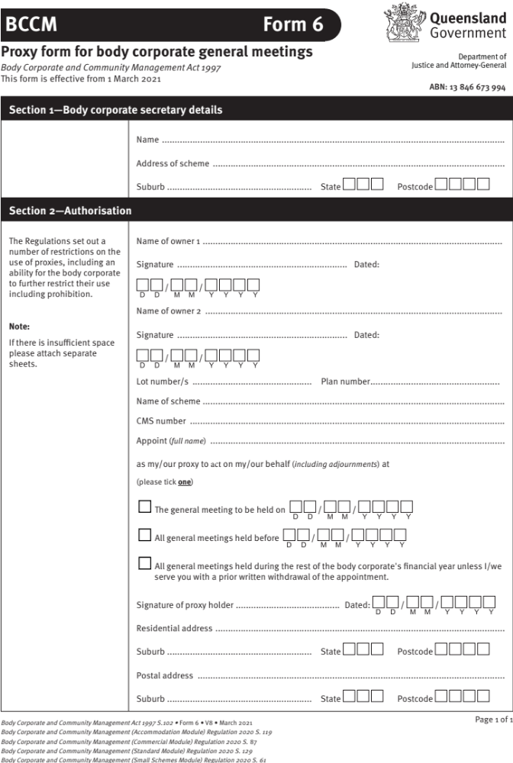

LOCATION OF MEETING: …
DATE & TIME OF MEETING: …
FOR THE DESCRIPTION: LOT: ....... UNIT: .......

If you want to vote using this voting paper, then mark either YES, NO or ABSTAIN (eg. by a circle) printed opposite each motion you wish to vote on. You may vote on as few or as many motions as you wish. It is not necessary to vote on all motions.

After signing the completed voting paper, forward it promptly to the Secretary at the address shown at the end of the agenda.

MOTIONS:

WHERE MOTIONS HAVE MULTIPLE OPTIONS THEY ARE GROUPED MOTIONS, INSTRUCTIONS ON THE CORRECT VOTING PROCEDURES ARE LISTED BELOW TO ASSIST YOU:

To vote on a group of same-issue motions, you may either vote in favour of, against, or abstain from voting on, each original motion in the group of same-issue motions. You may vote on more than 1 original motion.
Votes on each original motion in the group of same-issue motions will be counted in the order the original motions are listed in the agenda. When votes for all original motions have been counted, the original motion that receives the sufficient number of votes to pass according to the type of resolution required for the motion, and that also receives the highest number of votes in favour, is the decision of the body corporate about the group of same-issue motions. Only 1 original motion can be passed as the decision of the body corporate about the group of same-issue motions.
If no original motion receives the sufficient number of votes to pass according to the resolution required for the motion, the decision of the body corporate about the group of same-issue motions is that no original motion is passed.
Original motions in the group of same-issue motions cannot be amended at the meeting.

- ADOPTION OF MINUTES Ordinary Resolution YES / NO / ABSTAIN
Proposed by the Committee

That the minutes of the last general meeting held on ${LAST_MEETING_DATE} be confirmed and signed as a true and correct record of the proceedings at that meeting.

- STATEMENT OF ACCOUNTS Ordinary Resolution YES / NO / ABSTAIN
Proposed by the Committee, Statutory Motion

That the $statement$ of accounts showing a ${ADMIN_SURPLUS_DEFICIT} of ${EOY_ADMIN_BALANCE} in the administrative fund and a ${SINKING_SURPLUS_DEFICIT} of ${EOY_SINKING_BALANCE} in the sinking fund for the financial year ending on ${PREVIOUS_FYE} be approved.

- NO AUDIT Special Resolution YES / NO / ABSTAIN
Proposed by the Committee, Statutory Motion

That the body corporate's statement of accounts for the financial year ending on ${CURRENT_FYE} not be audited.

NOTE: If you want the accounts to be audited, vote ‘no’; if you do not want the accounts to be audited, vote ‘yes’.

- APPOINTMENT OF AUDITOR Ordinary Resolution YES / NO / ABSTAIN
Proposed by the Committee, Statutory Motion

That the body corporate's statement of accounts for the financial year ending on ${CURRENT_FYE} be audited by Dickfos Dunn Adam.

- ADMINISTRATION FUND LEVY Ordinary Resolution YES / NO / ABSTAIN
Proposed by the Committee, Statutory Motion

That the administrative fund budget totaling ${ADMIN_BUDGET} (expenses) for the financial year ending on ${CURRENT_FYE} be approved and that contributions be determined at the rate of ${ADMIN_CSLE} per Contribution Schedule Lot Entitlement (CSLE) due and payable by ${INSTALMENTS} instalments on the 1st day of each ${LEVY_ISSUE} in the following manner:-

Period Due Date Amount per CSLE

$P51$ $D51$ $A51$

$P52$ $D52$ $A52$

$P53$ $D53$ $A53$

$P54$ $D54$ $A54$

and further that an interim levy for the first ${LEVY_ISSUE} of the $newfiny$ financial year be issued at the rate of ${ADMIN_INTERIM_CSLE} per Contribution Schedule Lot Entitlement (CSLE) and be due and payable on ${NEW_FY_START}.

- INSURANCE LEVY Ordinary Resolution YES / NO / ABSTAIN
Proposed by the Committee, Statutory Motion

That the insurance fund contributions totalling $ifbudg$ for the year ending on ${CURRENT_FYE} be approved and that contributions be determined at the rate of $ifisle$ per Interest Schedule Lot Entitlement (ISLE) due and payable by $noinstal$ instalments on the 1st day of each $levyissue$ in the following manner:-

Period Due Date Amount per ISLE

$P61$ $D61$ $A61$

$P62$ $D62$ $A62$

$P63$ $D63$ $A63$

$P64$ $D64$ $A64$

and further that an interim levy for the first $levyissue$ of the $newfiny$ financial year be issued at the rate of $ifipe$ per Interest Schedule Lot Entitlement (ISLE) and be due and payable on $snewfinyear$.

- SINKING FUND LEVY Ordinary Resolution YES / NO / ABSTAIN
Proposed by the Committee, Statutory Motion

That the sinking fund budget totaling $sinkincome$ (income) for the financial year ending on ${CURRENT_FYE} be approved and that contributions be determined at the rate of $sinkcont$ per Contribution Schedule Lot Entitlement (CSLE) due and payable by $noinstal$ instalments on the 1st day of each $levyissue$ in the following manner:-

Period Due Date Amount per CSLE

$P71$ $D71$ $A71$

$P72$ $D72$ $A72$

$P73$ $D73$ $A73$

$P74$ $D74$ $A74$

and further that an interim levy for the first $levyissue$ of the $newfiny$ financial year be issued at the rate of $sinkintcont$ per Contribution Schedule Lot Entitlement (CSLE) and be due and payable on $snewfinyear$.

- INSURANCE Ordinary Resolution YES / NO / ABSTAIN
Proposed by the Committee, Statutory Motion

That the Insurance set out below be confirmed as adequate cover:-
INSURER: $insurer$
BROKER/INTERMEDIARY: $broker$
POLICY: $policy$
EXPIRY: $expiry$
PREMIUM: $premium$
COMMISSION: $commission$

INSURED PROPERTY (building) $insuredprop$
DEMOLITION FEES $demofee$
PROFESSIONAL FEES $proffee$
LEGAL LIABILITY $legalliability$
EXCESS: $excess$

NOTE: The body corporate must, at least every five years, obtain an independent valuation for the full replacement value of the building or buildings.

or

The current Valuation dated $dlvaluation$ recommended an insurance cover on the improvements and ancillary works in the event of total loss, to comply with the Act of $recsum$ ($amountinwords$).

- APPOINT BODY CORPORATE MANAGER Ordinary Resolution YES / NO / ABSTAIN
Proposed by the Committee, no proxies

That DCS Management Pty Ltd be appointed body corporate manager for a period of $bcmyears$ commencing on $bcmsd$ and ending on $bcmed$ at an annual fee of $bcmfee$ on the terms and conditions set out in the Administration Agreement circulated to owners.

- RE-APPOINT BODY CORPORATE MANAGER Ordinary Resolution YES / NO / ABSTAIN
Proposed by the Committee, no proxies

That DCS Management Pty Ltd be reappointed Body Corporate Manager from $bcmsd$ and ending on $bcmed$ in accordance with the terms and conditions set out in the existing Administration Agreement previously circulated to owners.

- ELECTRONIC VOTING Ordinary Resolution YES / NO / ABSTAIN
Proposed by the Committee

That the Body Corporate authorises voters at general meeting to record votes electronically for open motions by casting an electronic vote as per sections 94 and 96 of the Body Corporate and Community Management (Accommodation Module) Regulation 2020 (Qld).

OR

That the Body Corporate authorises voters at general meeting to record votes electronically for open motions by casting an electronic vote as per sections 104 and 106 of the Body Corporate and Community Management (Standard Module) Regulation 2020 (Qld).

OR

That the Body Corporate authorises voters at general meeting to record votes electronically for open motions by casting an electronic vote as per sections 62 and 64 of the Body Corporate and Community Management (Commercial Module) Regulation 2020 (Qld).

- GENERAL MEETING QUORUM Special Resolution YES / NO / ABSTAIN
Proposed by the Committee

That, in accordance with Section 99 of the Body Corporate and Community Management (Standard Module) Regulation 2020, the body corporate determines that to constitute a quorum at a general meeting the number of voters required to be present in person is one (1) and the minimum percentage of voters required is 10%.

- GENERAL MEETING QUORUM Special Resolution YES / NO / ABSTAIN
Proposed by the Committee

That, in accordance with Section 89 of the Body Corporate and Community Management (Accommodation Module) Regulation 2020, the body corporate determines that to constitute a quorum at a general meeting the number of voters required to be present in person is one (1) and the minimum percentage of voters required is 10%.

- $M9TITLE$ $M9RES$ YES / NO / ABSTAIN
$M9PROP$

$M9DETAILS$

- $M10TITLE$ $M10RES$ YES / NO / ABSTAIN
$M10PROP$

$M10DETAILS$

- $M11TITLE$ $M11RES$ YES / NO / ABSTAIN
$M11PROP$

$M11DETAILS$

- $M12TITLE$ $M12RES$ YES / NO / ABSTAIN
$M12PROP$

$M12DETAILS$

PLEASE NOTE THAT THE FOLLOWING MOTIONS PROPOSED ARE GROUPED MOTIONS, INSTRUCTIONS ON THE CORRECT VOTING PROCEDURES ARE LISTED BELOW TO ASSIST YOU:

To vote on this group of same-issue motions, you may either vote in favour of, against, or abstain from voting on, each original motion in the group of same-issue motions. You may vote on more than 1 original motion.
Votes on each original motion in the group of same-issue motions will be counted in the order the original motions are listed in the agenda. When votes for all original motions have been counted, the original motion that receives the sufficient number of votes to pass according to the type of resolution required for the motion, and that also receives the highest number of votes in favour, is the decision of the body corporate about the group of same-issue motions. Only 1 original motion can be passed as the decision of the body corporate about the group of same-issue motions.
If no original motion receives the sufficient number of votes to pass according to the resolution required for the motion, the decision of the body corporate about the group of same-issue motions is that no original motion is passed.
Original motions in the group of same-issue motions cannot be amended at the meeting.

- $M13TITLE$ $M13RES$ YES / NO / ABSTAIN
$M13PROP$

$M13DETAILS$

- GROUP OF SAME ISSUE MOTIONS – …

$M14TITLE$ $M14RES$ YES / NO / ABSTAIN
$M14PROP$

$M14DETAILS$

$M15TITLE$ $M15RES$ YES / NO / ABSTAIN
$M15PROP$

$M15DETAILS$

